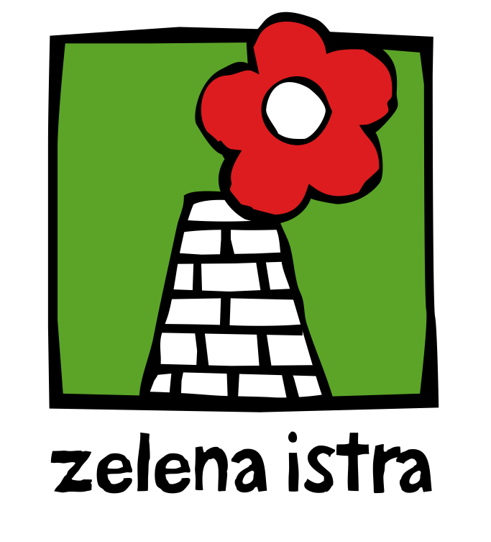
Strategic Impact Assessment
SEMINAR
Opatija, Hotel Admiral, 6 - 8 October, 2011

Thursday, 6 October

15:00 - 15:30 Introduction - Tomislav Tomašević, Green Action / Dušica Radojčić, Green Istria

15:30 - 16:00 Impact assessment (what, why, who, how) - Peggy Lerman

16:00 - 16:40 What is SEA (requirements of the SEA Directive, definition, principles) - Csaba Kiss

16:40 - 17:00 Coffee break

17:00 - 17:40 What is SEA - continuation - Peggy Lerman (benefits, methods...)

17:40 - 18:10 Post-decision monitoring in EIA / SEA ("hows" and "whys", comparing predicted and actual effects, improving future SEAs/EIAs) - Peggy Lerman, Csaba Kiss

18:10 - 19:00 SEA in Croatia (current legal framework, practice) - Anamarija Matak, Ministry of Environmental Protection, Physical Planning and Construction, Head of the Impact Assessment Department

Dinner (for seminar participants situated in the hotel)

Friday, 7 October

09:00 - 9:45 Public participation and impact assessment (democratic effectiveness of EIA and SEA) - Peggy Lerman

09:45 - 11:15 EIA and SEA practical examples
EIA for tourist developments (golf course with holiday living, Nature 2000) - Peggy Lerman
SEA for water management plan - Csaba Kiss
Harbour dredging, road planning - Peggy Lerman

11:15 - 11:30 Coffee break
11:30 - 13:00 SEA practical examples
SEA of sector plans and programs (Hungarian legislation) - Csaba Kiss
SEA in land use planning (regional physical plan of Stockholm) - Peggy Lerman, Kristiina Kosunen Eriksson
SEA of sector plans and programs (energy plans) - Peggy Lerman

13:00 - 16:00 Lunch break (lunch from 13:00 – 14:00, leisure time until 16:00)

16:00 - 16:30 SEA in the legislative and policy processes - Peggy Lerman, Kristiina Kosunen Eriksson

16:30 - 16:50 SEA experience in the EU (Report on the Study on the implementation and effectiveness of the European Union Directives on SEA commissioned by the European Commission) - Csaba Kiss

16:50 - 17:15 EIA and SEA recent developments and issues, challenges - Csaba Kiss

17:15 - 17:30 "SEA Implementation and Practice: Making an Impact?" - report from the 2011 Prague Conference - Enes Čerimagić

17:30 - 17:50 Coffee break

17:50 - 18:10 Health impact assessment, social and economic impacts - Peggy Lerman

18:10 - 18:30 Questions and Introduction to the practical exercise - Dušica Radojčić

Saturday, 8 October

09:00 - 11:00 Practical exercise
SEA for the Istrian County Spatial Plan amendments - Lerman, Kiss

11:00 - 11:20 Coffee break

11:20 - 12:50 Practical exercise - continuation

12:50 - 13:00 Closure - Dušica Radojčić

13:00 Closing lunch (after the program end)

Strateška procjena utjecaja na okoliš
SEMINAR
Opatija, Hotel Admiral, 6. - 8. listopada 201.

Četvrtak, 6. listopad

15:00 - 15:30 Uvod - Tomislav Tomašević, Zelena akcija / Dušica Radojčić, Zelena Istra

15:30 - 16:00 Procjena utjecaja (što, zašto, tko, kako) - Peggy Lerman

16:00 - 16:40 Što je SPUO (Direktiva o SPUO, definicija, principi) - Csaba Kiss

16:40 - 17:00 Pauza za kavu

17:00 - 17:40 Što je SPUO - nastavak - Peggy Lerman (koristi, metode...)

17:40 - 18:10 Praćenje provedbe PUO i SPUO (razlozi, usporedba previđenog i stvarnog utjecaja, učenje iz grešaka za buduće postupke) - Peggy Lerman, Csaba Kiss

18:10 - 19:00 SPUO u Hrvatskoj (zakonodavni okvir i praksa) - Anamarija Matak, Ministarstvo zaštite okoliša, prostornog uređenja i graditeljstva, načelnica Odjela za pocjenu utjecaja

Večera (za sudionike smještene u hotelu)

Petak, 7. listopad

09:00 - 9:45 Sudjelovanje javnosti u procjeni utjecaja (demokratska učinkovitost PUO i SPUO) - Peggy Lerman

09:45 - 11:15 PUO I SPUO - primjeri iz prakse
PUO za turističke projekte (golf s turističkim smještajem, Natura 2000)
- Peggy Lerman
SPUO za plan upravljanja vodama - Csaba Kiss
Jaružanje luka, planiranje cesta - Peggy Lerman

11:15 - 11:30 Pauza za kavu

11:30 - 13:00 SPUO - primjeri iz prakse
SPUO za sektorske planove i programe (mađarsko zakonodavstvo) - Csaba Kiss
SPUO u prostornom planiranju (prostorni plana grada Stockholma) - Peggy Lerman, Kristiina Kosunen Eriksson
SPUO a sektorske planove i programe (energetski plan) - Peggy Lerman

13:00 - 16:00 Ručak (vrijeme ručka 13:00 – 14:00, slobodno vrijeme do 16:00)

16:00 - 16:30 SPUO u zakonodavnom procesu i javnim politikama - Peggy Lerman, Kristiina Kosunen Eriksson

16:30 – 16:50 Europska iskustva sa SPUO (Izvještaj Europske komisije o provedbi i učinkovitosti Direktive o SPUO) - Csaba Kiss

16:50 - 17:15 Recentni trendovi u PUO i SPUO (poteškoće, izazovi) - Csaba Kiss

17:15 - 17:30 "Provedba i praksa SPUO: Što je s učinkom?" - izvještaj s konferencije o SPUO održane u Pragu 2011. - Enes Čerimagić

17:30 - 17:50 Pauza za kavu

17:50 - 18:10 Procjena utjecaja na zdravlje, procjena društvenih i ekonomskih učinaka - Peggy Lerman

18:10 - 18:30 Pitanja i uvod u sutrašnju vježbu - Dušica Radojčić

Subota, 8. listopada

09:00 - 11:00 Vježba na primjeru iz prakse
SPUO za izmjene i dopune Prostornog plana Istarske županije - Lerman, Kiss

11:00 - 11:20 Pauza za kavu

11:20 - 12:50 Vježba na primjeru iz prakse - nastavak

12:50 - 13:00 Završna riječ - Dušica Radojčić

13:00 Završni ručak (nakon završetka programa)

